**Assignment1:**

Package :org.system

Class :Computer

Methods :computerModel()

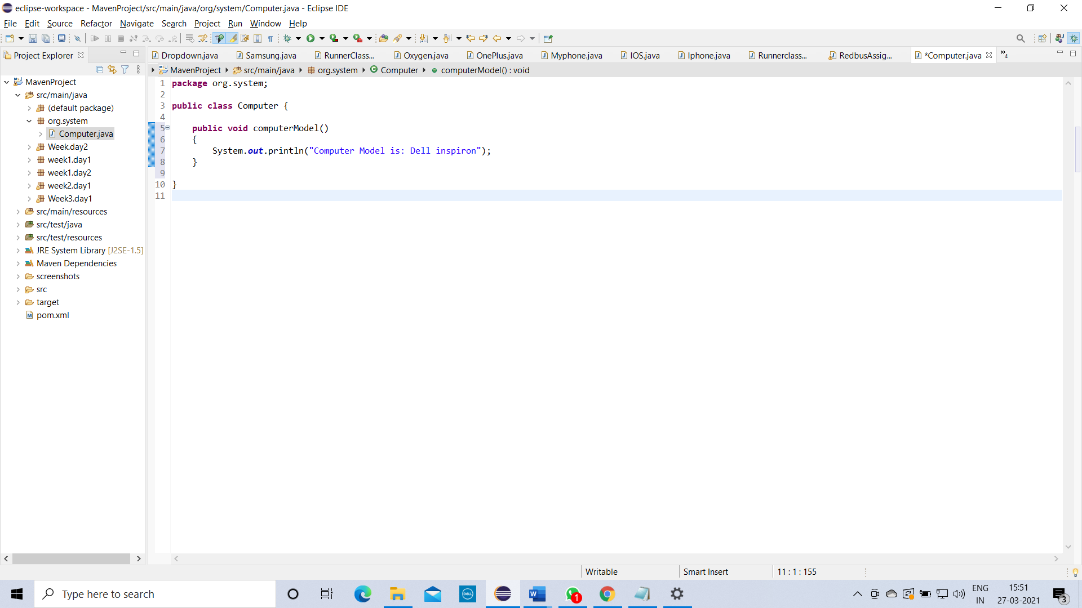

Class :Desktop

Methods :desktopSize()

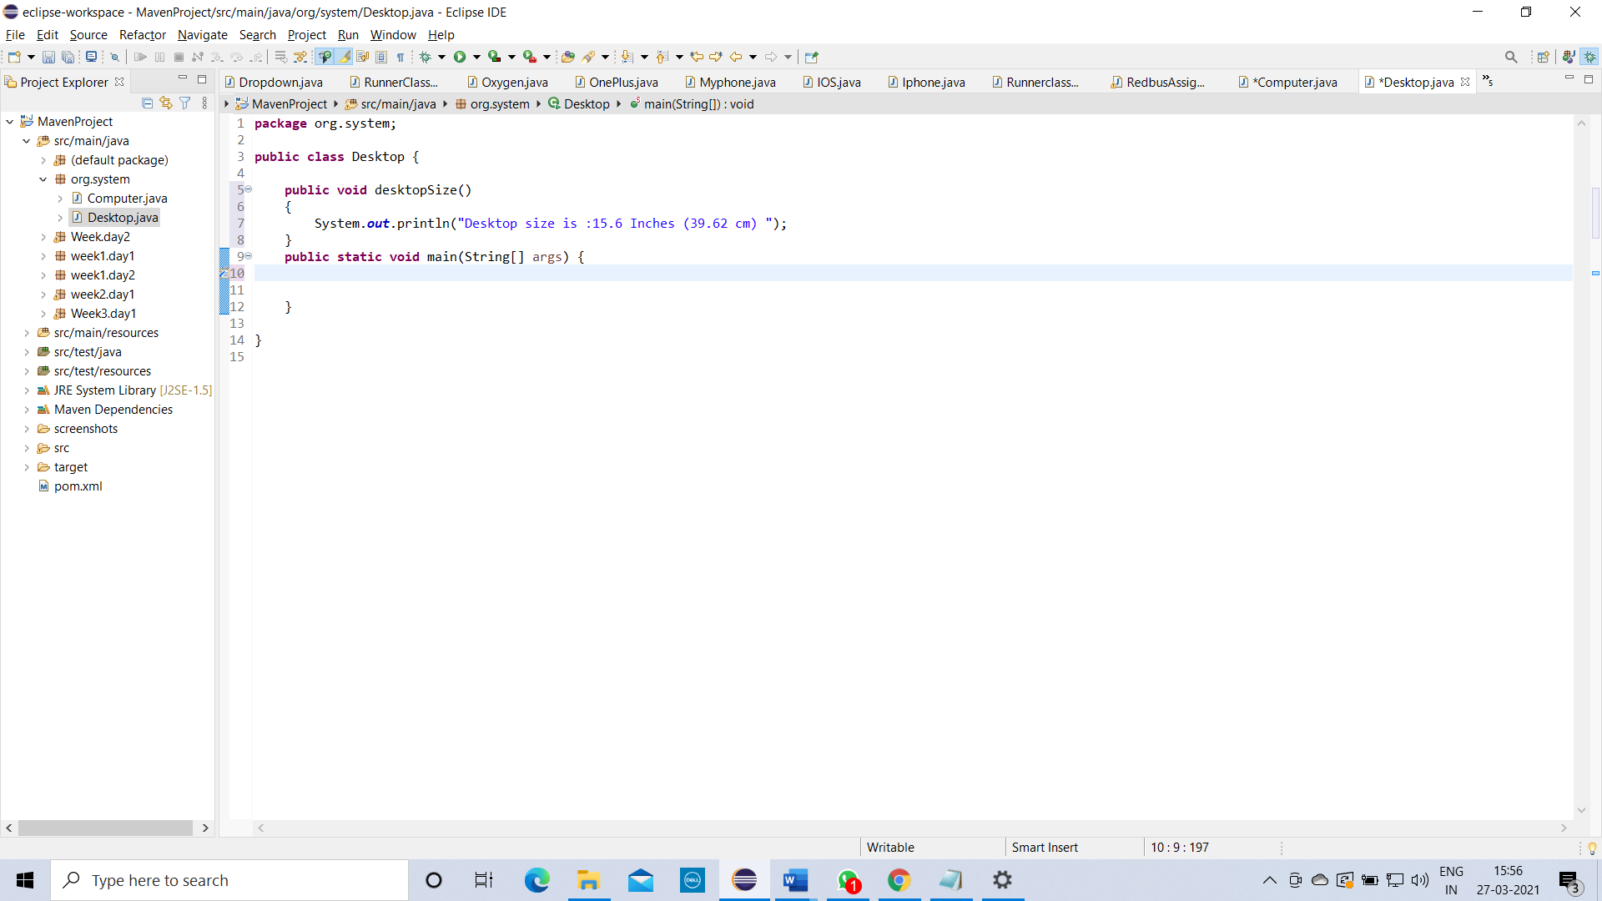

create above 2 class and call all your class methods into the Desktop using single inheritance.

